OOP Phase 1

Name - Akassharjun Shanmugarajah

IIT ID - 2018387

UoW ID - w1743207

Table of Contents

Console App Use Case Diagram 2

GUI Application Use Case Diagram 3

Class Diagram 4

Vehicle Class 5

Car Class 6

Motorbike Class 7

RentalVehicleManager Interface 8

WestminsterRentalVehicleManager Class 9

Date Class 10

Schedule class 12

Make enum 13

StandType enum 13

Transmission enum 13

# Console App Use Case Diagram

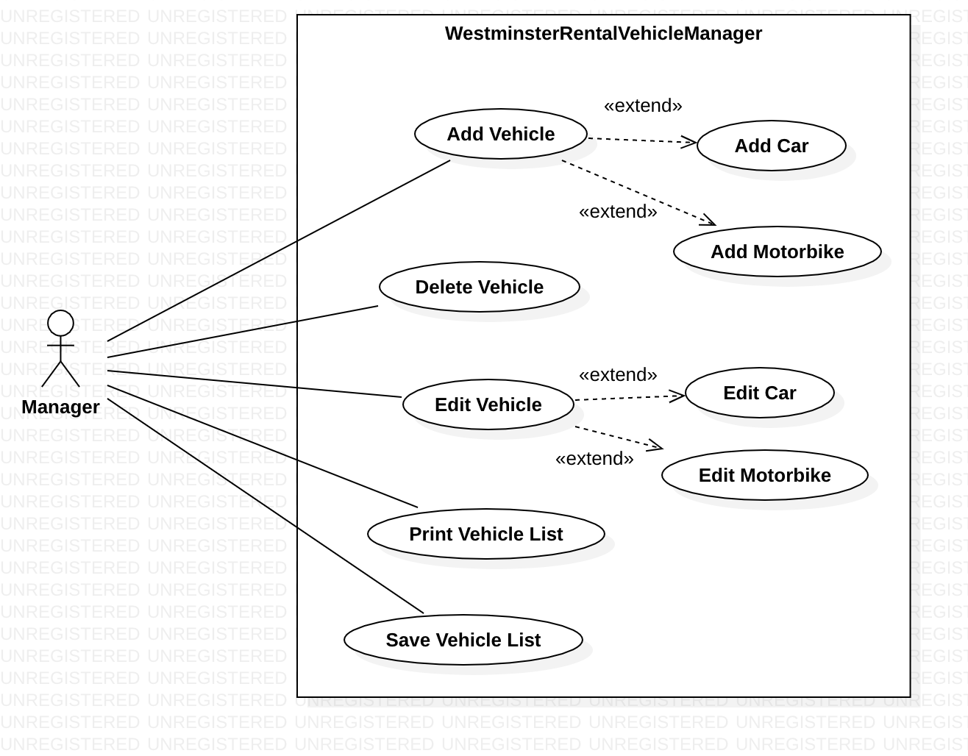

# GUI Application Use Case Diagram

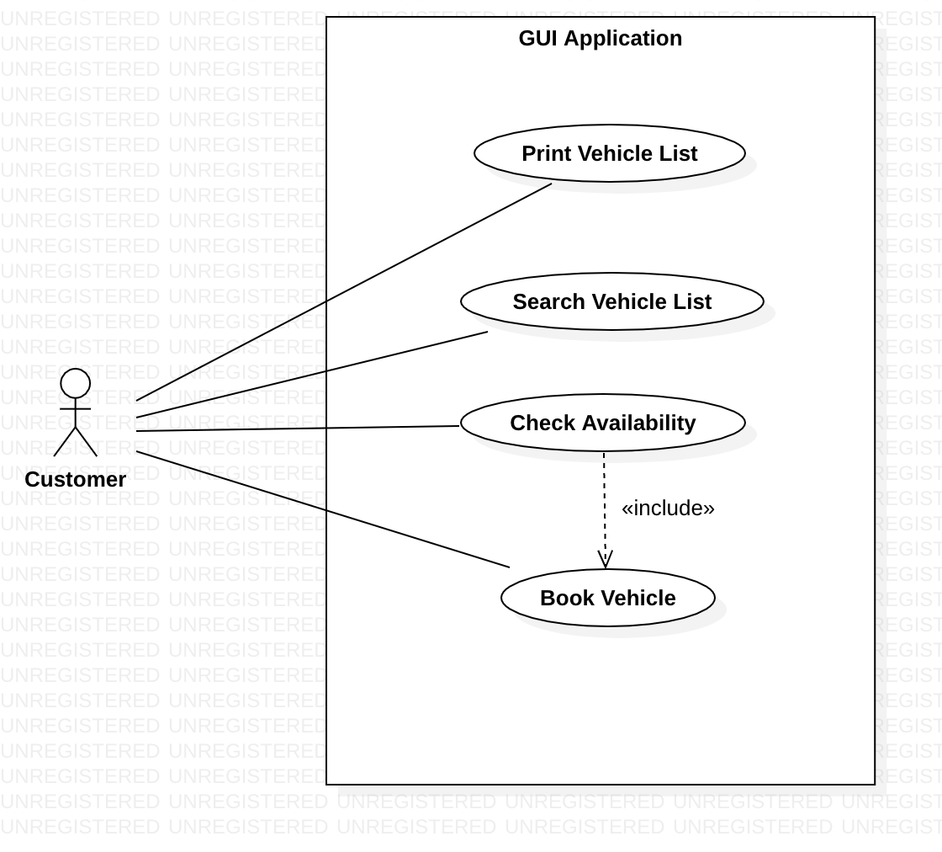

# Class Diagram

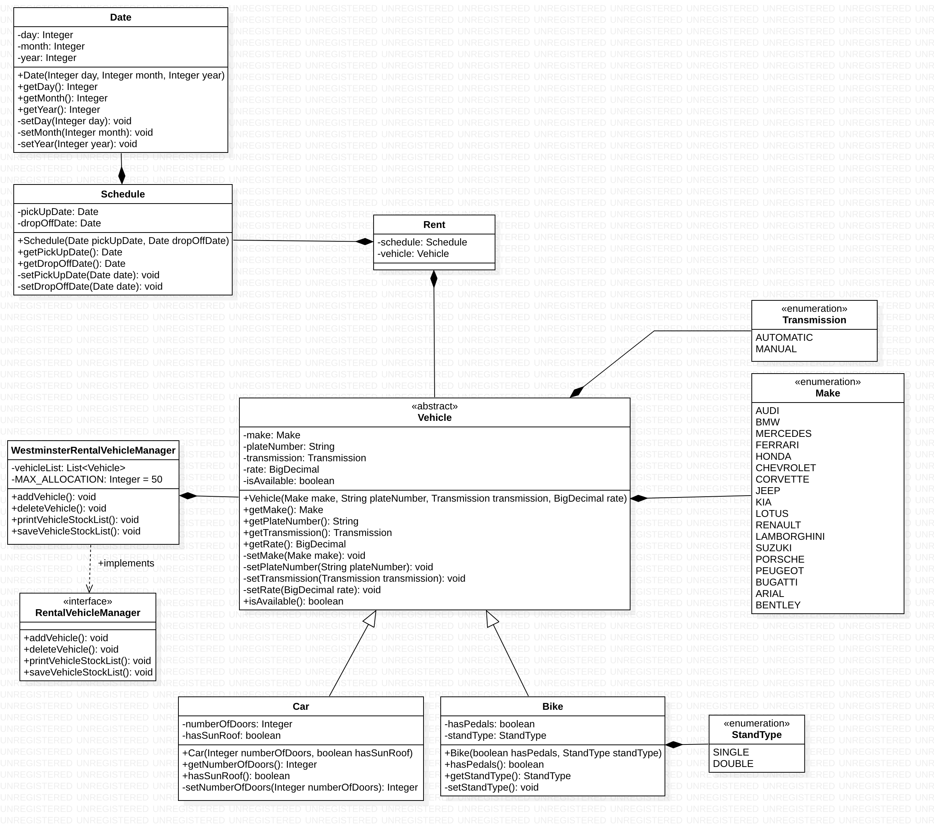

# Vehicle Class

**package** model;  
  
**import** java.math.BigDecimal;  
  
**public** **abstract** **class** Vehicle {  
 **protected** Make make;  
 **protected** String plateNumber;  
 **protected** Transmission transmission;  
 **protected** BigDecimal rate;  
 **protected** boolean isAvailable;  
  
 **public** Vehicle(Make make, String plateNumber, Transmission transmission, BigDecimal rate, boolean isAvailable) {  
 this.make = make;  
 this.plateNumber = plateNumber;  
 this.transmission = transmission;  
 this.rate = rate;  
 this.isAvailable = isAvailable;  
 }  
  
 **public** Make getMake() {  
 return make;  
 }  
  
 **public** String getPlateNumber() {  
 return plateNumber;  
 }  
  
 **private** **void** setPlateNumber(String plateNumber) {  
 // add validation for plate number  
 this.plateNumber = plateNumber;  
 }  
  
 **private** **void** setTransmission(Transmission transmission) {  
 this.transmission = transmission;  
 }  
  
 **public** BigDecimal getRate() {  
 return rate;  
 }  
  
 **public** boolean isAvailable() {  
 return isAvailable;  
 }  
}

# Car Class

**package** model;  
  
**import** java.math.BigDecimal;  
  
**public class** Car **extends** Vehicle {  
 **private int numberOfDoors**;  
 **private boolean hasSunRoof**;  
  
 **public** Car(Make make, String plateNumber, Transmission transmission, BigDecimal rate, **boolean** isAvailable, **int** numberOfDoors, **boolean** hasSunRoof) {  
 **super**(make, plateNumber, transmission, rate, isAvailable);  
 **this**.**numberOfDoors** = numberOfDoors;  
 **this**.**hasSunRoof** = hasSunRoof;  
 }  
  
 **public int** getNumberOfDoors() {  
 **return numberOfDoors**;  
 }  
  
 **public boolean** hasSunRoof() {  
 **return hasSunRoof**;  
 }  
}

# Motorbike Class

**package** model;  
  
**import** java.math.BigDecimal;  
  
**public class** Motorbike **extends** Vehicle {  
 **private boolean hasPedals**;  
 **private** StandType **standType**;  
  
 **public** Motorbike(Make make, String plateNumber, Transmission transmission, BigDecimal rate, **boolean** isAvailable, **boolean** hasPedals, StandType standType) {  
 **super**(make, plateNumber, transmission, rate, isAvailable);  
 **this**.**hasPedals** = hasPedals;  
 **this**.**standType** = standType;  
 }  
  
 **public boolean** hasPedals() {  
 **return hasPedals**;  
 }  
  
 **public** StandType getStandType() {  
 **return standType**;  
 }  
}

# RentalVehicleManager Interface

**import** model.Vehicle;  
  
**import** java.util.ArrayList;  
**import** java.util.List;  
  
**public interface** RentalVehicleManager {  
  
 **public abstract void** addVehicle();  
  
 **public abstract void** deleteVehicle();  
  
 **public abstract void** printVehicleStockList();  
  
 **public abstract void** saveVehicleStockList();  
  
}

# WestminsterRentalVehicleManager Class

**import** model.Vehicle;  
  
**import** java.util.ArrayList;  
**import** java.util.List;  
  
**public class** WestminsterRentalVehicleManager **implements** RentalVehicleManager {  
 List<Vehicle> **vehicleList** = **new** ArrayList<>();  
  
 @Override  
 **public void** addVehicle() {  
 *// add vehicle* }  
  
 @Override  
 **public void** deleteVehicle() {  
 *// delete vehicle* }  
  
 @Override  
 **public void** printVehicleStockList() {  
  
 }  
  
 @Override  
 **public void** saveVehicleStockList() {  
  
 }  
}

# Date Class

**package** model;  
  
**import** java.util.Objects;  
  
**public class** Date {  
 **private int day**;  
 **private int month**;  
 **private int year**;  
  
 **public** Date(**int** day, **int** month, **int** year) {  
 **this**.setDay(day);  
 **this**.setMonth(month);  
 **this**.setYear(year);  
 }  
  
 **public int** getDay() {  
 **return day**;  
 }  
  
 **public int** getMonth() {  
 **return month**;  
 }  
  
 **public int** getYear() {  
 **return year**;  
 }  
  
 **private void** setDay(**int** day) {  
 *// checking for leap year* **if** (**this**.**month** == 2) {  
 **if** (**this**.**year** % 4 == 0) {  
 **if** (day <= 0 || day > 29) {  
 **throw new** IllegalArgumentException(**"Day should be in range of 1-29"**);  
 }  
 **this**.**day** = day;  
 } **else** {  
 **if** (day <= 0 || day > 28) {  
 **throw new** IllegalArgumentException(**"Day should be in range of 1-28"**);  
 }  
 **this**.**day** = day;  
 }  
 } **else if** (day > 31 || day < 1) {  
 **throw new** IllegalArgumentException(**"Day should be in range of 1-31"**);  
 }  
  
 **this**.**day** = day;  
 }  
  
 **private void** setMonth(**int** month) {  
 **if** (month > 12 || month < 1) {  
 **throw new** IllegalArgumentException(**"Month should be in range of 1-12"**);  
 }  
 **this**.**month** = month;  
 }  
  
 **private void** setYear(**int** year) {  
 **if** (year > 2019 || year < 1) {  
 **throw new** IllegalArgumentException(**"Year should be in range of 1-2019"**);  
 }  
 **this**.**year** = year;  
 }  
  
 @Override  
 **public boolean** equals(Object o) {  
 **if** (**this** == o) **return true**;  
 **if** (!(o **instanceof** Date)) **return false**;  
 Date date = (Date) o;  
 **return day** == date.**day** &&  
 **month** == date.**month** &&  
 **year** == date.**year**;  
 }  
  
 @Override  
 **public int** hashCode() {  
 **return** Objects.*hash*(**day**, **month**, **year**);  
 }  
}

# Schedule class

**package** model;  
  
**public class** Schedule {  
 **private** Date **pickUpDate**;  
 **private** Date **dropOffDate**;  
  
 **public** Schedule(Date pickUpDate, Date dropOffDate) {  
 **this**.setPickUpDate(pickUpDate, dropOffDate);  
 **this**.**dropOffDate** = dropOffDate;  
 }  
  
 **public** Date getPickUpDate() {  
 **return pickUpDate**;  
 }  
  
 **private void** setPickUpDate(Date pickUpDate, Date dropOffDate) {  
 *// validate dates* **this**.**pickUpDate** = pickUpDate;  
 }  
  
 **public** Date getDropOffDate() {  
 **return dropOffDate**;  
 }  
  
 **public void** setDropOffDate(Date dropOffDate) {  
 *// validate dates* **this**.**dropOffDate** = dropOffDate;  
 }  
}

# Make enum

**package** model;  
  
**public enum** Make {  
 ***AUDI***,  
 ***BMW***,  
 ***BENTLEY***,  
 ***BUGATTI***,  
 ***CHEVROLET***,  
 ***CORVETTE***,  
 ***FERRARI***,  
 ***HONDA***,  
 ***KIA***,  
 ***JEEP***,  
 ***LOTUS***,  
 ***LAMBORGHINI***,  
}

# StandType enum

**package** model;  
  
**public enum** StandType {  
 ***SINGLE***,  
 ***DOUBLE***}

# Transmission enum

**package** model;  
  
**public enum** Transmission {  
 ***MANUAL***,  
 ***AUTOMATIC***}